PROBABILITY TREE
Pearson Edexcel – Monday 8 June 2020 - Paper 3 (Calculator) Higher Tier
1.
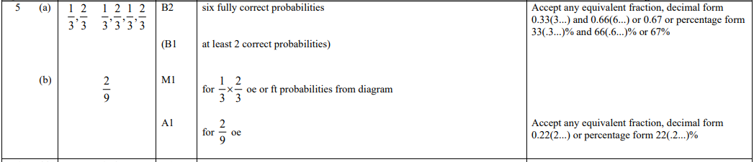
Pearson Edexcel - Thursday 6 June 2019 - Paper 2 (Calculator) Higher Tier
2.
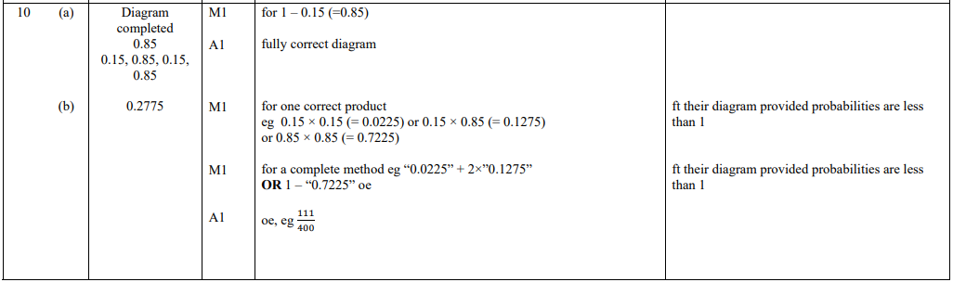
Pearson Edexcel - Thursday 7 June 2018 - Paper 2 (Calculator) Higher Tier
3.
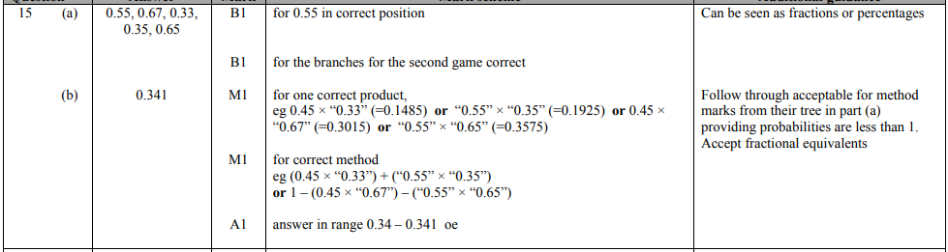
Pearson Edexcel - Tuesday 12 June 2018 - Paper 3 (Calculator) Higher Tier
4.
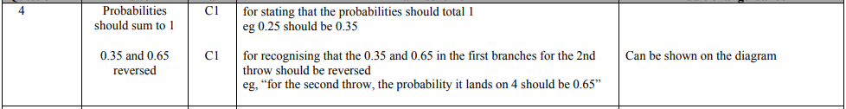
Pearson Edexcel - Wednesday 8 November 2017 - Paper 3 (Calculator) Higher Tier
5.
Pearson Edexcel - Thursday 8 June 2017 - Paper 2 (Calculator) Higher Tier
6.
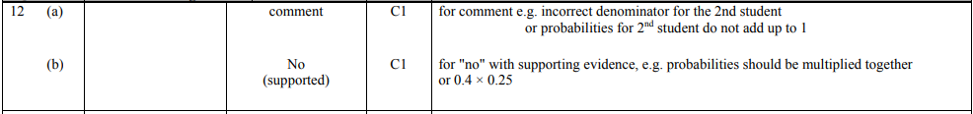
Pearson Edexcel - Specimen Papers Set 1 - Paper 2 (Calculator) Higher Tier
7.
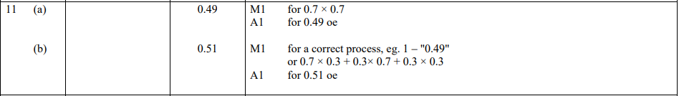
Pearson Edexcel - Sample Paper 2 - (Calculator) Higher Tier
8.
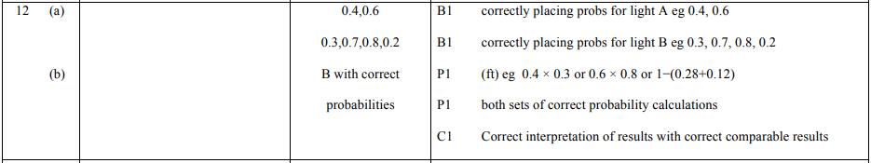
Pearson Edexcel - Thursday 26 May 2016 - Paper 1 (Non-Calculator) Higher Tier
9.
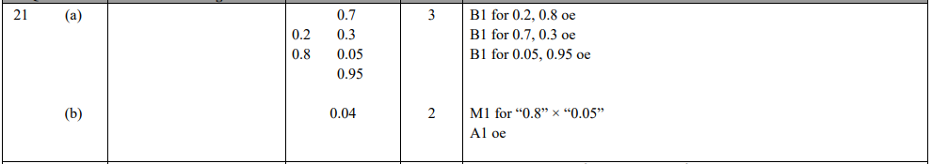
Pearson Edexcel - Friday 7 November 2014 - Paper 2 (Calculator) Higher Tier
10.
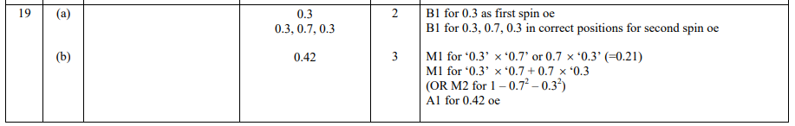
Pearson Edexcel - Monday 9 June 2014 - Paper 1 (Non-Calculator) Higher Tier
11.
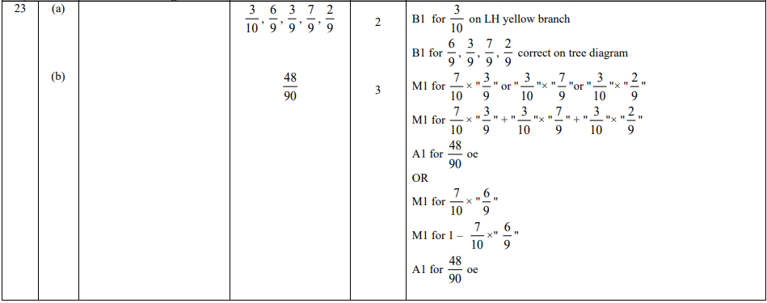
Pearson Edexcel - Monday 11 June 2012 - Paper 1 (Non-Calculator) Higher Tier
12.
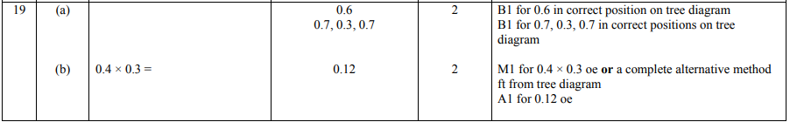
Pearson Edexcel - Friday 2 March 2012 - Paper 3 (Non-Calculator) Higher Tier
13.
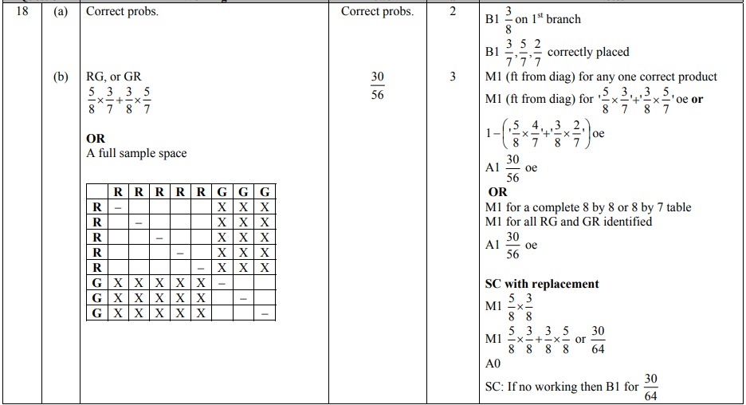
Pearson Edexcel - Wednesday 9 November 2011 - Paper 3 (Non-Calculator) Higher Tier
14.
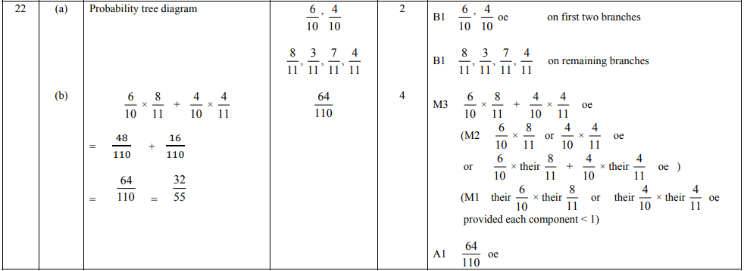
Pearson Edexcel - Thursday 5 November 2009 - Paper 3 (Non-Calculator) Higher Tier
15.
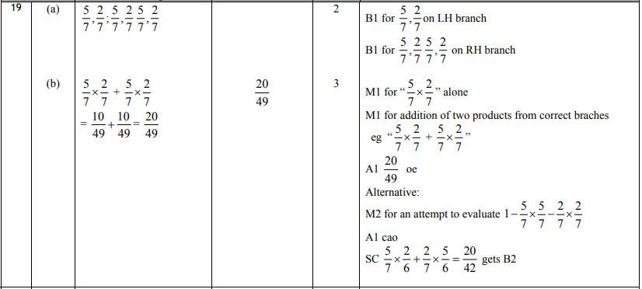
OCR GSCE – Thursday 5 November 2020 – Paper 5 (Non-Calculator) Higher Tier
16.
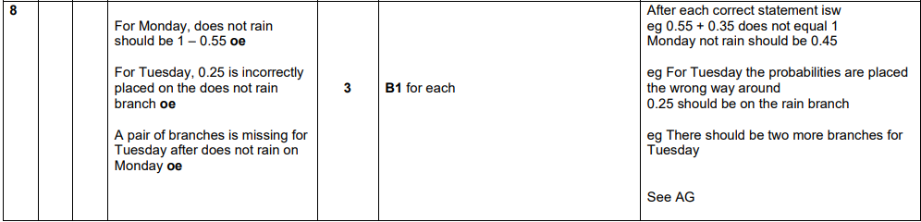
OCR GSCE – Thursday 6 June 2019 – Paper 5 (Non-Calculator) Higher Tier
17.
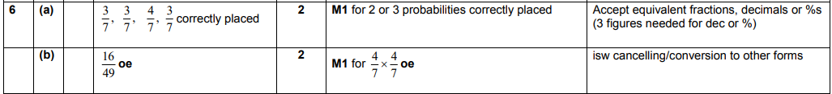
OCR GSCE – Monday 12 November 2018 – Paper 6 (Calculator) Higher Tier
18.
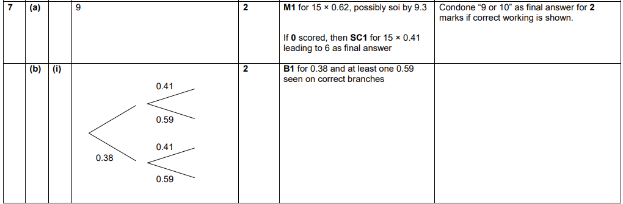
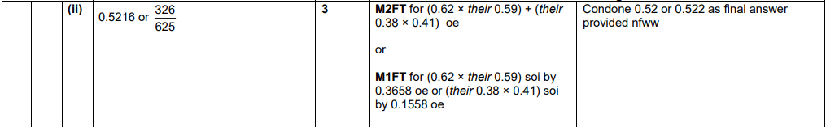
OCR GSCE – Wednesday 8 November 2017 – Paper 6 (Calculator) Higher Tier
19.
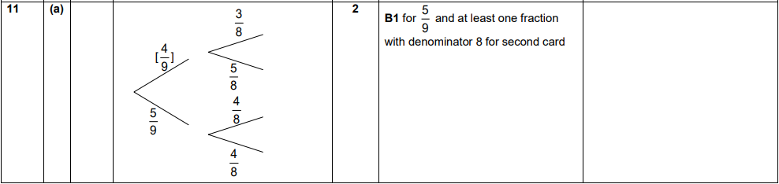
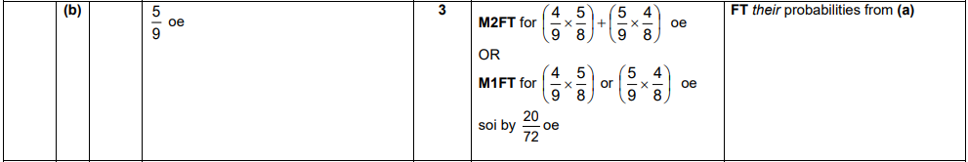
OCR GSCE – Thursday 25 May 2017 – Paper 4 (Calculator) Higher Tier
20.
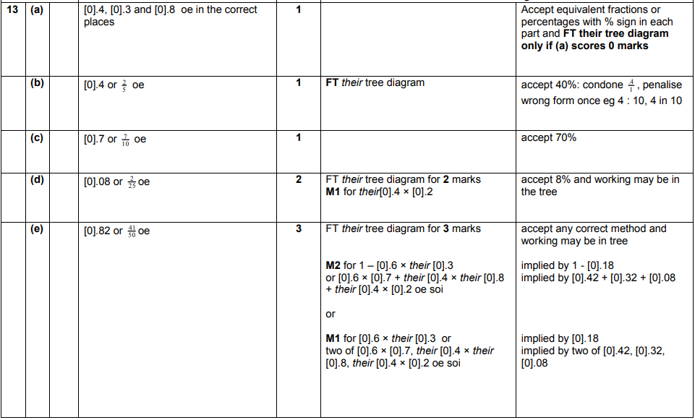
AQA GSCE – Tuesday 21 May 2019 – Paper 1 (Non - Calculator) Higher Tier
21.
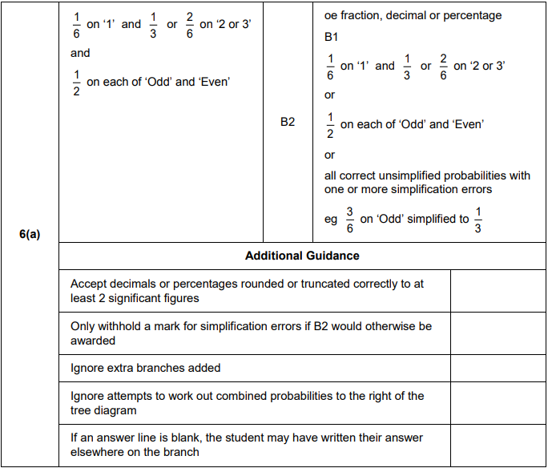
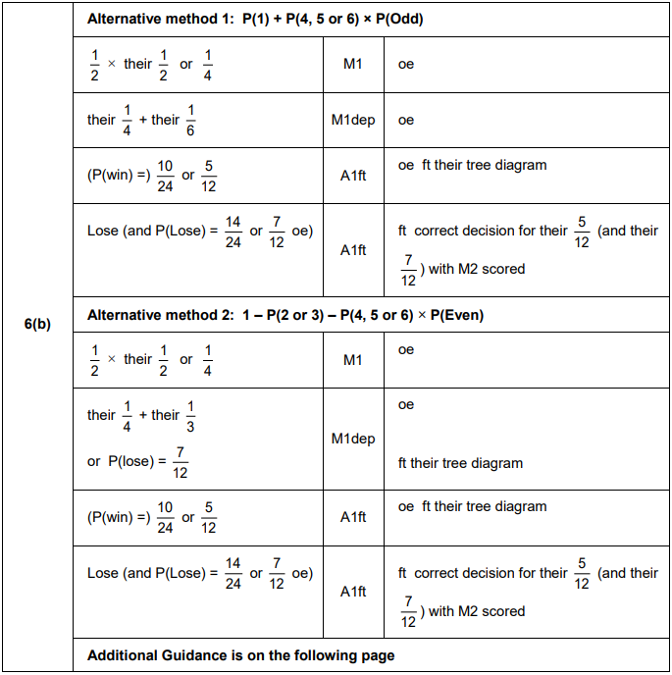
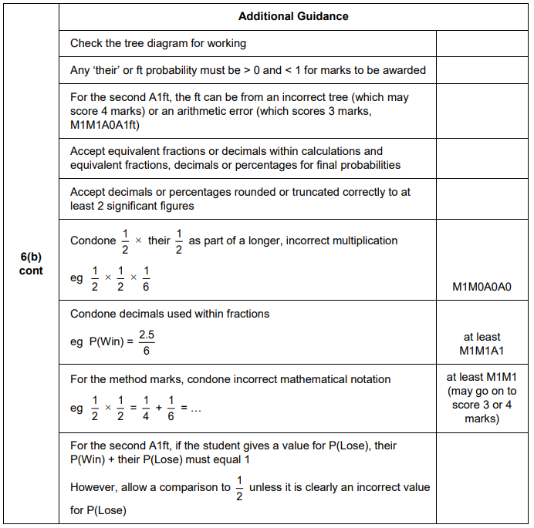
AQA GSCE – Thursday 7 June 2018 – Paper 2 (Calculator) Higher Tier
22.
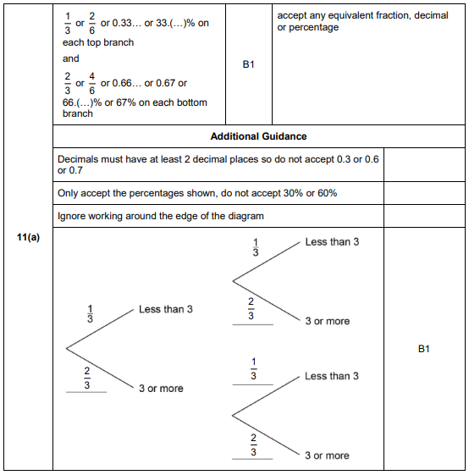
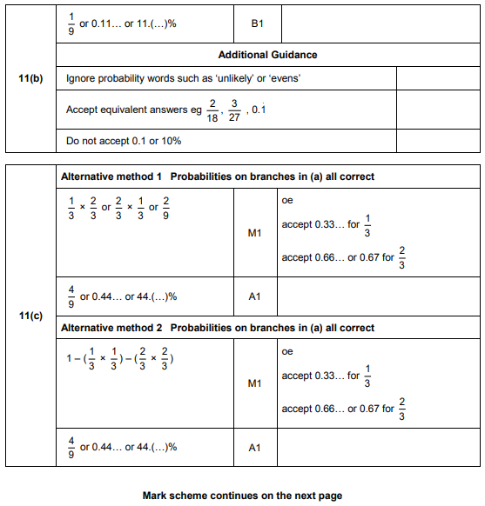
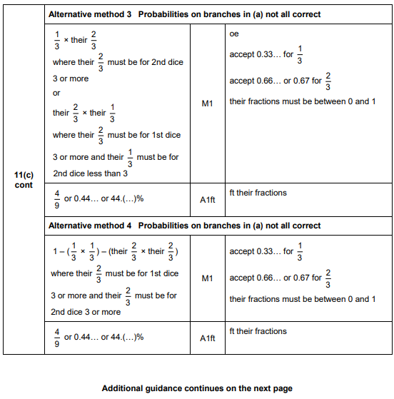
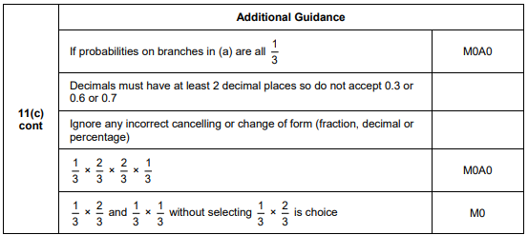

AQA GSCE – Wednesday 25 May 2017 – Paper 1 (Non - Calculator) Higher Tier
23.
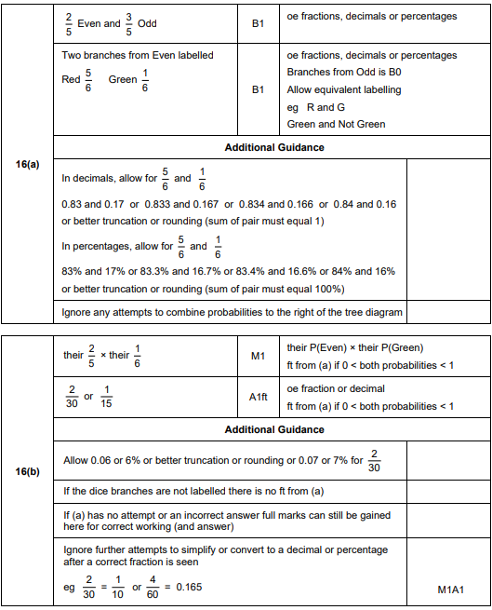
AQA GSCE – Sample Paper 1 (Non - Calculator) Higher Tier
24.
